Section I: Scenario Demographics

Scenario Title: | Non Accidental Injury- Shaken Baby
Date of Development: | (11/01/2018)
Target Learning Group: | Juniors (PGY 1 – 2) Seniors (PGY ≥ 3) All Groups

Section II: Scenario Developers

Scenario Developer(s): | Suzan Schneeweiss
Affiliations/Institution(s): | Sick Kids Learning Institute
Contact E-mail (optional):

Section III: Curriculum Integration

Learning Goals & Objectives
Educational Goal: | To review the management of a seizing infant with non-accidental head injury
CRM Objectives: | - Effectively lead a team through care of a critically ill infant  - Demonstrate high quality closed-loop communication during resuscitation  - Sensitively address the patient’s mother and notify re: team concerns regarding non-accidental injury
Medical Objectives: | - Rapidly estimate pediatric weight for medication dosing and resuscitation equipment  - Manage seizures in the newborn  - Recognize the presentation of possible non-accidental injury  - Lead team through intubation after airway maneuvers unsuccessful

Case Summary: Brief Summary of Case Progression and Major Events
The team has been called to help in the ED after a 1 month-old male is brought in seizing. The team is expected to manage the seizure, but then will subsequently realize on examination there are concerning signs for non-accidental trauma, specifically head injury. The team will be expected to establish definitive airway management and consult with PICU and local child protection services.

References
Marx, J. A., Hockberger, R. S., Walls, R. M., & Adams, J. (2013). Rosen's emergency medicine: Concepts and clinical practice. St. Louis: Mosby.
https://www.cps.ca/en/documents/position/convulsive-status-epilepticus

Section IV: Scenario Script

A. Scenario Cast & Realism
Patient: | Computerized Mannequin |  |  |  |  | Realism:  Select most important dimension(s) |  |  | Conceptual
 | Mannequin |  |  |  |  |  |  |  | Physical
 | Standardized Patient |  |  |  |  |  |  |  | Emotional/Experiential
 | Hybrid |  |  |  |  |  |  |  | Other:
 | Task Trainer |  |  |  |  |  |  |  | N/A
Confederates | Brief Description of Role
Nurse | To assist at bedside, describe infant’s status, and provide history.
B. Required Monitors
EKG Leads/Wires |  |  | Temperature Probe |  |  |  | Central Venous Line
NIBP Cuff |  |  | Defibrillator Pads |  |  |  | Capnography
Pulse Oximeter |  |  | Arterial Line |  |  |  | Other:
C. Required Equipment
Gloves |  |  | Nasal Prongs |  |  |  | Scalpel
Stethoscope |  |  | Venturi Mask |  |  |  | Tube Thoracostomy Kit
Defibrillator |  |  | Non-Rebreather Mask |  |  |  | Cricothyroidotomy Kit
IV Bags/Lines |  |  | Neonatal Bag Valve Mask |  |  |  | Thoracotomy Kit
IV Push Medications |  |  | Laryngoscope |  |  |  | Central Line Kit
PO Tabs |  |  | Video Assisted Laryngoscope |  |  |  | Arterial Line Kit
Blood Products |  |  | Neonatal ET Tubes |  |  |  | Other: Radiant warmer
Intraosseous Set-up |  |  | LMA |  |  |  | Other:
D. Moulage
Boggy swelling left parietal area
Bruising on back

E. Approximate Timing
Set-Up: |  | 3 min |  | Scenario: | 15 min |  |  | Debriefing: |  | 20 min

Section V: Patient Data and Baseline State

A. Clinical Vignette: To Read Aloud at Beginning of Case
A 1 month-old male is brought into the ED due to poor feeding and lethargy. The baby was apparently well until this morning, when his mom noticed it was difficult to wake and feed him. There has been no fever. The baby vomited once this morning, and is voiding and stooling normally.

The nurse in triage notices abnormal movements and brings the baby in to your team in the resuscitation room.
B. Patient Profile and History
Patient Name: Cody |  |  |  |  |  | Age: 30 days |  |  |  |  |  |  |  | Weight: 4 kg
Gender: M F
Chief Complaint: Seizing baby
History of Presenting Illness: Poor feeding and lethargy x 1 day, starts seizing at triage
Past Medical History: |  | Full term 39 weeks |  |  |  |  | Medications: |  |  |  |  | None
 |  | GBS negative
 |  | No PROM
Allergies: None
Social History: Lives with mother and her boyfriend. Mother attends college part time.
Family History: None
Review of Systems: |  | CNS: |  |  | Difficult to wake baby for feeds today
 |  | HEENT: |  |  | Nil
 |  | CVS: |  |  | Nil
 |  | RESP: |  |  | Nil
 |  | GI: |  |  | Vomited once this morning. Stooling normally.
 |  | GU: |  |  | Normal urine output.
 |  | MSK: |  |  | Nil |  |  |  |  |  |  |  | INT: |  | Nil.
C. Baseline Simulator State and Physical Exam
No Monitor Display |  |  |  | Monitor On, no data displayed |  |  |  |  |  |  | Monitor on Standard Display
HR: 180/min |  |  | BP: 80/p |  |  |  |  | RR: 22/min |  |  |  |  |  |  | O₂SAT: 92%
Rhythm: Sinus with background artifact |  |  | T: 36.5ºC |  |  |  |  | Glucose: 2.0 mmol/L
General Status: Actively seizing
CNS: | Pupils dilated, sluggish, tonic clonic movement of 4 limbs
HEENT: | Boggy swelling over left parietal area
CVS: | Sinus tachycardia, HR 160
RESP: | Shallow respirations
ABDO: | Soft, NT
GU: | Nil
MSK: | Nil |  |  |  |  |  |  |  | SKIN: | Bruises to back/buttocks area

Section VI: Scenario Progression
Scenario States, Modifiers and Triggers
Patient State | Patient Status | Learner Actions, Modifiers & Triggers to Move to Next State
1. Baseline State  Rhythm: Sinus tachycardia  HR: 180/min  BP: 80/p  RR: 22/min  O₂SAT: 92%  T: 36.5ºC | Actively seizing | Learner Actions  - Apply 100% O2, monitors  - Obtain IV access  - Labs including tox screen and blood cultures  - Check cap sugar: 2.0  - Obtains weight from RN (4 kg), or uses Broselow tape  - IV D10W, 5ml/kg (20ml)  - IV Ativan 0.1 mg/kg, or IM midazolam 0.2 mg/kg  - Asks for overbed warmer/radiant warmer  - Call RT | Modifiers  Changes to patient condition based on learner action  - Only D10 given seizure continues  - If no overbed warmer, RN to cue “he’s starting to feel cold”  Triggers  For progression to next state  - Benzos + D10 given 2. Post ictal
2. Post-ictal  HR: 160/min  BP: 80/p  RR: 6, shallow  O₂SAT: 80% | Pale, lethargic, grunting. No longer seizing. | Learner Actions  - Jaw thrust, suction airway  - Call RT (if not yet done)  - Begin BVM at rate 20  - IV NS bolus 10-20 cc/kg  - Re-Check cap sugar: 4.4  - IV Ampicillin (50 mg/kg), Cefotaxime (50 mg/kg), and acyclovir (20mg/kg)  - Recognize signs of head injury/non-accidental trauma  - IV phenobarbital (20mg/kg)  - Prepare for intubation | Modifiers  - No jaw thrust, O₂ SpO2 70%  - Jaw thrust, O₂ SpO2 85%  - RN to prompt: “What’s with this bruising on his head? I noticed something on his back, too.”  Triggers  - Preparing to intubate  3. Persistent apnea  - 5 minutes into state  3. Persistent apnea
3. Persistent apnea  HR: 140/min  BP: 80/p  RR: 0  O₂SAT: 80% |  | Learner Actions  - Prepare for intubation  - Ketamine 1.5-2mg/kg OR  - Fentanyl 1.5-2 mcg/kg  - Rocuronium 0.6-1mg/kg  - Atropine (0.02 mg/kg) at bedside or given, Epi at bedside  - Appropriate size tube  (3 cuffed, 3.5 uncuffed) and tube depth (9 cm) | Modifiers  - No plan to intubate RN to trigger “how long are we going to continue bagging for?”  Triggers  - Successful intubation  4. Disposition
4. Disposition  HR: 140  BP: 80/p  RR: 20 (vented)  O₂SAT: 95% |  | Learner Actions  - Post intubation CXR  - Initiate sedation  - Arrange CT head  - Discuss trauma concerns with parent  - Consult PICU  - Call child protective services | END CASE PRN

Section VII: Supporting Documents, Laboratory Results, & Multimedia

Laboratory Results
No bloodwork is provided during the case.

Images (ECGs, CXRs, etc.)
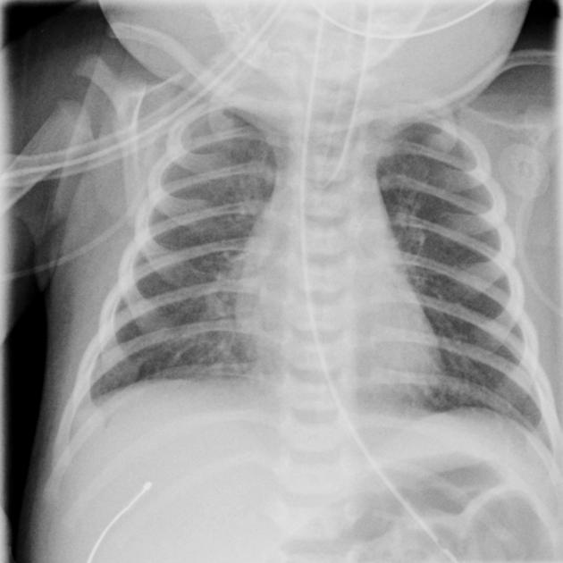
(CXR source: https://radiopaedia.org/articles/neonatal-pneumonia)
Ultrasound Video Files (if applicable)
None required.

Section VIII: Debriefing Guide

General Debriefing Plan
Individual | Group |  | With Video | Without Video
Objectives
Educational Goal: |  | To review the management of a seizing infant with non-accidental head injury
CRM Objectives: |  | - Effectively lead a team through care of a critically ill infant  - Demonstrate high quality closed-loop communication during resuscitation  - Sensitively address the patient’s mother and notify re: team concerns regarding non-accidental injury
Medical Objectives: |  | - Rapidly estimate pediatric weight for medication dosing and resuscitation equipment  - Manage seizures in the newborn  - Recognize presentation of possible non-accidental injury  - Lead team through intubation after airway maneuvers unsuccessful
Sample Questions for Debriefing
1. What are some common non-accidental injury patterns in pediatrics?
2. What is in the differential diagnosis for a seizing infant?
3. If IV access was not successful, what other routes and doses of anti-epileptic medications could you use?
4. How did the decision to intubate feel? Were all members on the same page? Did the intubation run smoothly?
5. How did it feel to raise concerns for non-accidental trauma with the parent?
Key Moments
Recognition of seizing infant and need check glucose and start first line anti-epileptics
Recognition of apnea and establishment of definitive airway
Recognition of non accidental injury and appropriate consultation

